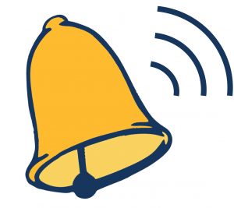RAA MIDDLE SCHOOL

**Bell Schedule**

**Opening Bell** 9:25 A.M.

**1st period** 9:30 – 10:25

**2nd period** 10:29 – 11:19

**3rd period**  11:23 – 1:08

11:20 – 11:44 – 1st Lunch (24 min)

11:48 – 12:12 – 2nd Lunch (24 min)

12:16 – 12:40 – 3rd Lunch (24 min)

12:44 – 1:08 – 4th Lunch (24 min)

1st Lunch **HR**– 12:42 – 1:08 (26 min) **Instruction** - 11:46 – 12:42 (56 min)

2nd Lunch **HR**– 11:23 – 11:47 (24 min) **Instruction** - 12:14 – 1:08 (54 min)

3rd Lunch **HR** - 12:42 – 1:08 (26 min) **Instruction** - 11:23 – 12:15 (52 min)

4th Lunch **HR**– 12:18 – 12:43 (25 min) **Instruction** - 11:23 – 12:18 (55 min)

**4th period** 1:12 – 2:02

**5th period**  2:06 – 2:56

**6th period** 3:00 – 3:50

**Dismissal** 3:50 – 4:05

**\*During the school day, students are dismissed by the teacher not the bell. At the end of the school day, students are dismissed via the intercom to walk, buses or parent pick up.**

**Rams Lead! Rams Inspire! Rams Serve!**